Skipped

1. 26, 27, 28

Important Points

1. **Scalability**:
   1. When we talk about Scalability in Kafka, it is in terms of how much parallelly we can read and write from a Kafka Cluster.
   2. So, the more brokers we add, then the more parallelly, we can read/write from/to Kafka Cluster.
   3. Scaling out here means to increase reading and writing from/to Kafka Cluster parallelly.
   4. Scaling is possible due to partition of a topic.
2. **Durable**: When msg is stored in Leader Broker.   
   **Fault-Tolerant**: When msg is stored in Follower Brokers.   
   **Fully-Committed**: In other words, when a msg is persisted in the Leader as well as the followers in the ISR list, we consider the msg to be fully committed.
3. Two consumers cannot read from the same partition to avoid double reading.

So Maximum number of consumers are limited by the number of partitions (Leaders not followers).  
**Example**: If we have 10 partitions, then only maximum 10 consumers are allowed.  
 Yes, if we have 5 consumers, then each consumer will consume from two partitions.

1. One broker may have multiple partitions (Refer 25. Partition Leader vs Partition Follower)
2. Reasons to create partitions from a Topic.
   1. A broker server doesn’t have enough space to store all msgs inside a topic.
   2. A file can’t contain a huge amount of data.
   3. Parallel Processing.
3. KafkaProducer is thread safe.
4. #Brokers >= replication-factor #
5. **ISR**: Maintaining a separate list of brokers having in sync replicas.
   1. Suppose B1 is leader for P1 and B2 is follower for P1 partition.  
      P1-ISR (List) containing B1,B2 🡨 This says that B1, B2 brokers have a sync replica and in case B1 is down, B2 is good candidate for new leader position.  
      Similarly, one ISR list for another partition P2 will be maintained like P2-ISR.

1. What is Apache Kafka

1. 
2.   
   **It has following two meanings**:   
   Realtime Stream of Data Pipeline.
3. **Real-time Example**: Smart Meters generating data related data every minute and sending to **Kafka Server**.  
   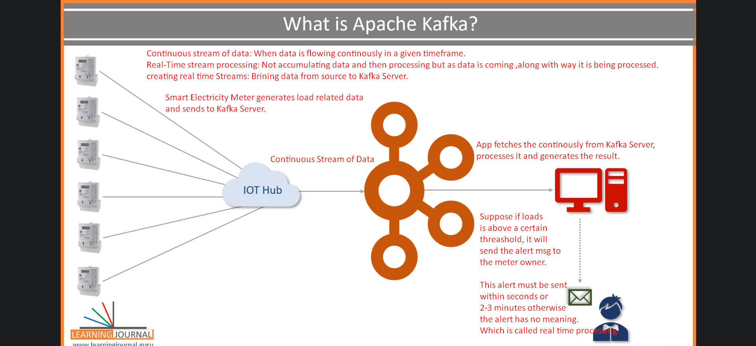
4. 
5. 
6. Apache Kafka adopted **Pub-Sub Messaging System Architecture** and works as an **Enterprise Messaging System**.
7. **Three components of a messaging system** 🡺 Producer(Publisher), Broker, & Consumer (Subscriber).

1. 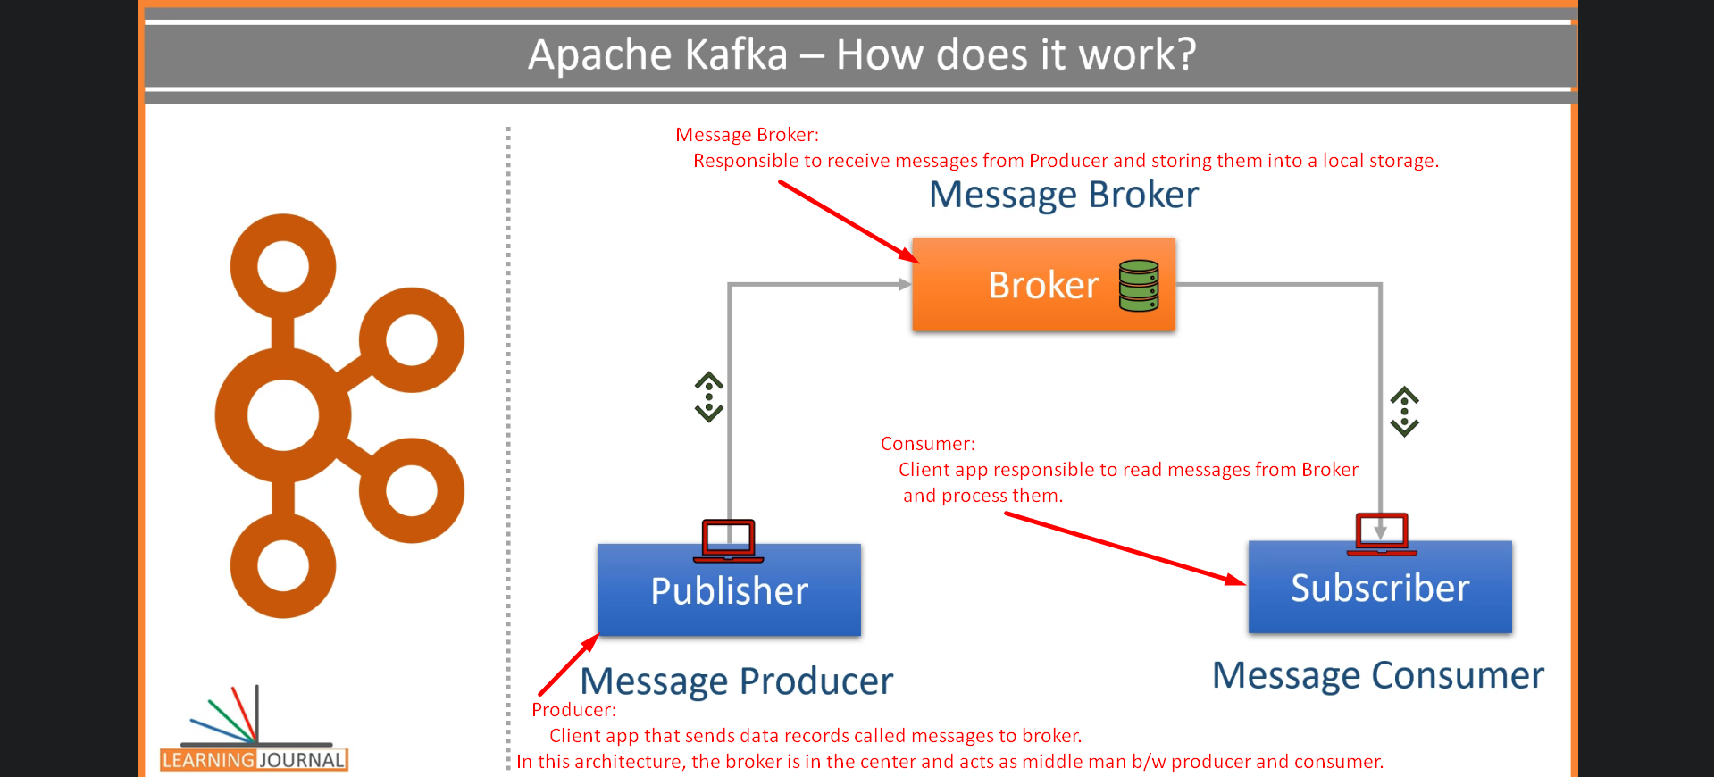  
   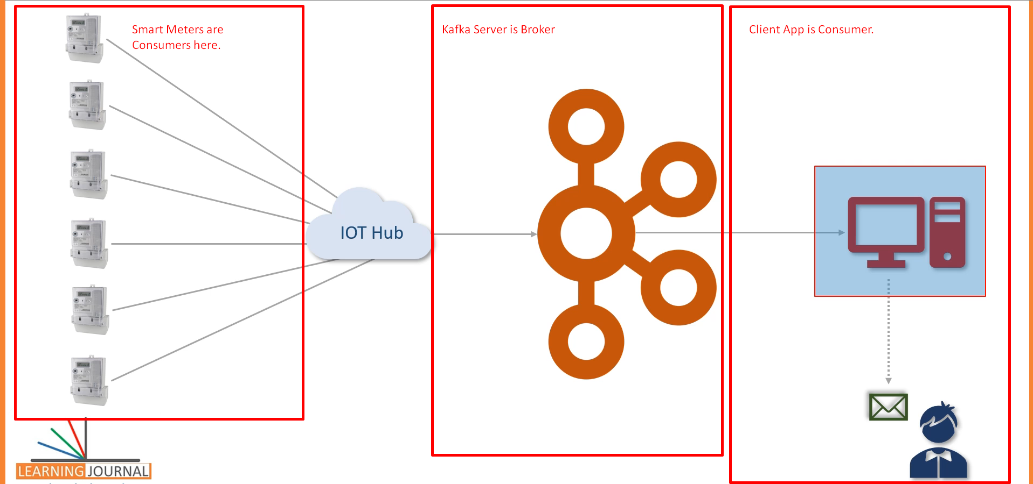

Kafka works as **Pub-Sub Messaging System** where we create a **Producer App** to create and send data **as a stream**.   
We install and configure **Kafka Server** to act as **a message Broker**.  
Finally, we create **consumer app** to process the **data stream** in **realtime**.

1. 
2. Kafka was initially conceptualized and developed at **Linkedin** and later on **open sourced** in 2011 to solve Data Integration
3. 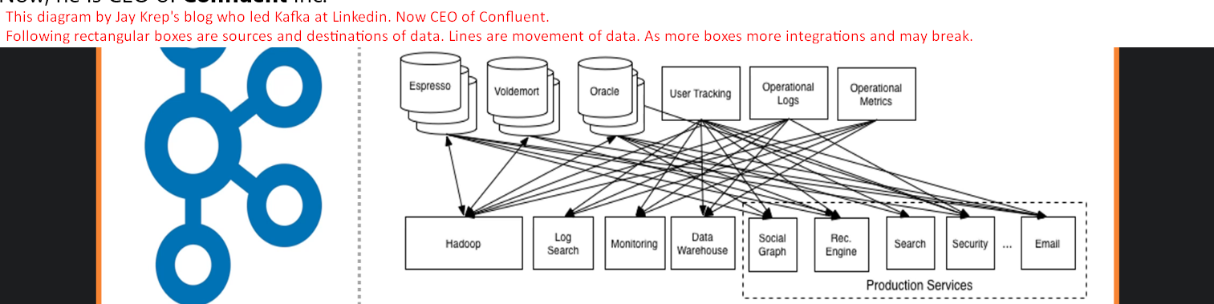
4. 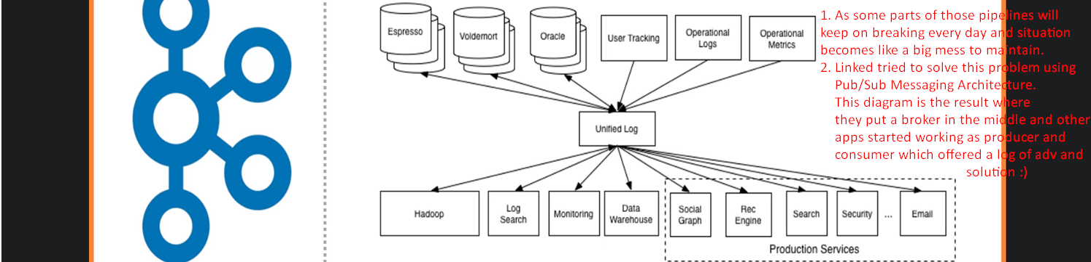
5. 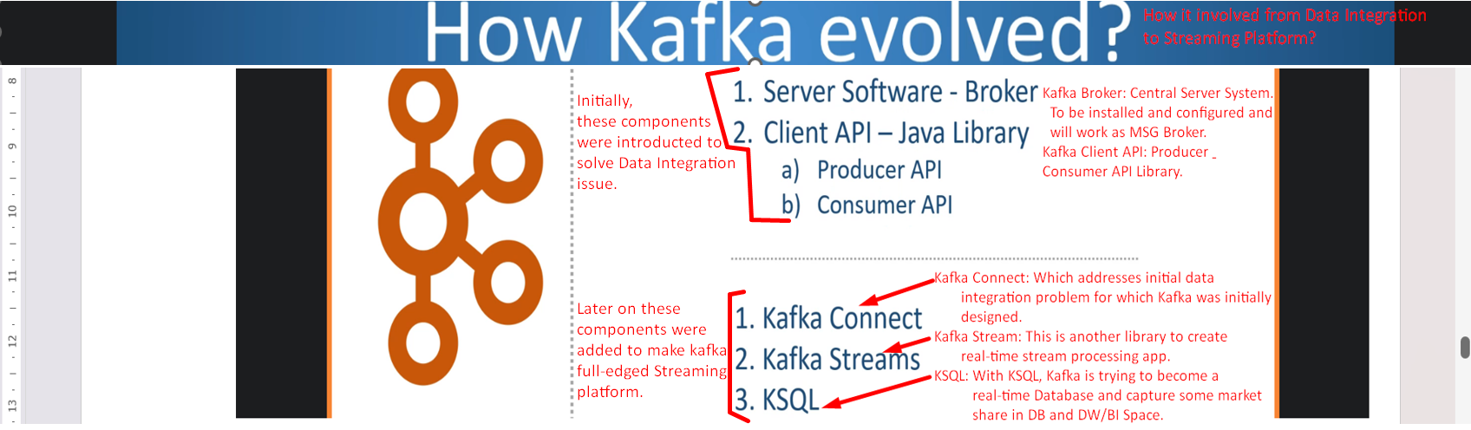
6. 
7. 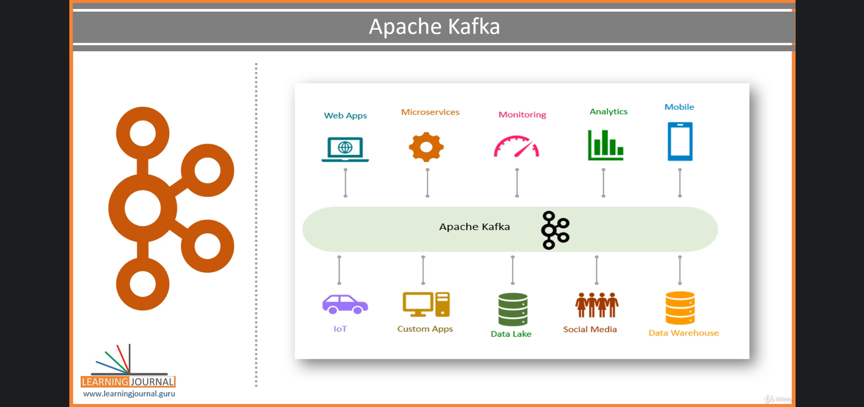

2. Apache Kafka Core Concepts

1. 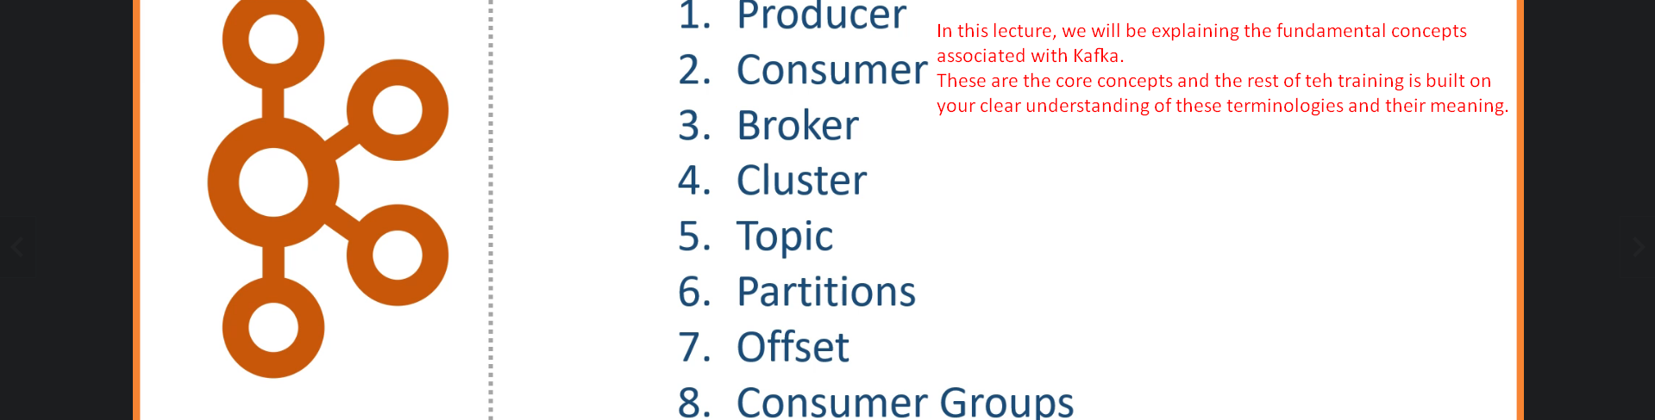
2. Producer is app sending data (msg, msg record) from small to medium sized.
   1. Msg may have any record structure schema but for kafka it is an **array of bytes.**
   2. **Example**:  
      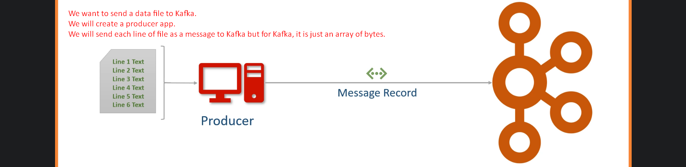  
      Other examples may be like sending a table or result set from a query.   
      So, basically create appropriate Producer App as per your requirement.
3. **Consumer**:
   1. Recipient. Producer doesn’t send directly to consumer but via Broker/Kafka Server. 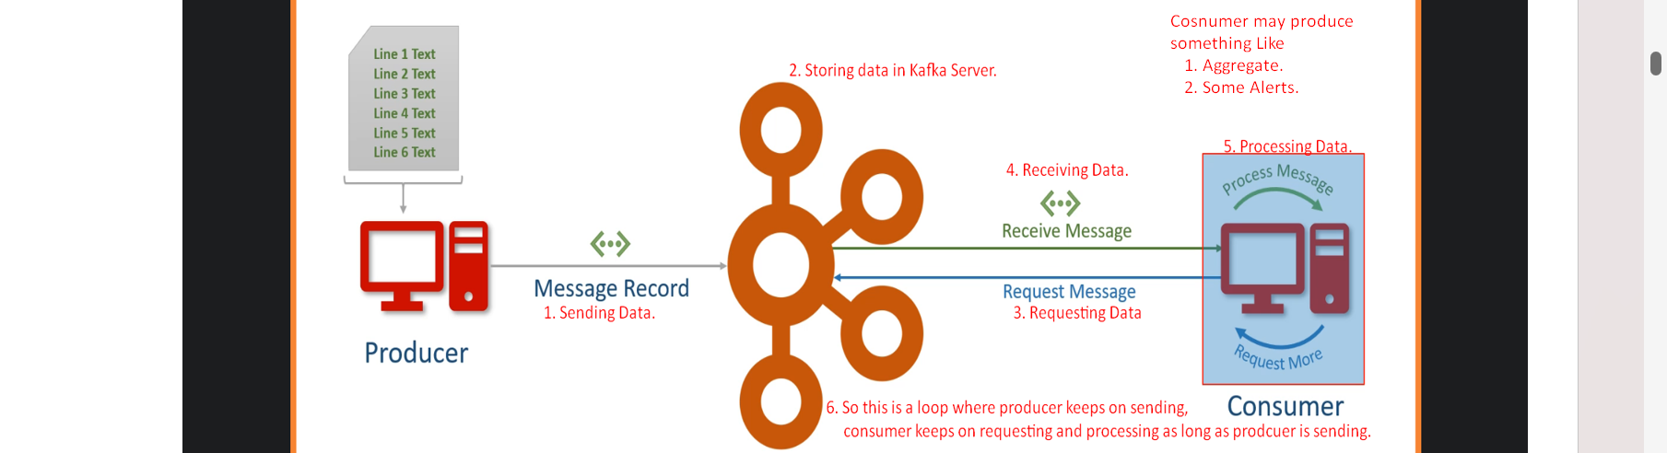
4. **Broker**:
   1. Kafka Server as an agent or a broker to exchange messages.
5. **Cluster**:
   1. Kafka Cluster is a group of computers each running an instance of Kafka Server/Broker for a single purpose.
6. **Kafka Topic**:
   1. **Examples**: Current Load, Consumed Units, Input Fluctuations which one you want.
   2. Arbitrary but unique Name given to a data set. Think like a DB Table Name which is design time decision.
   3. 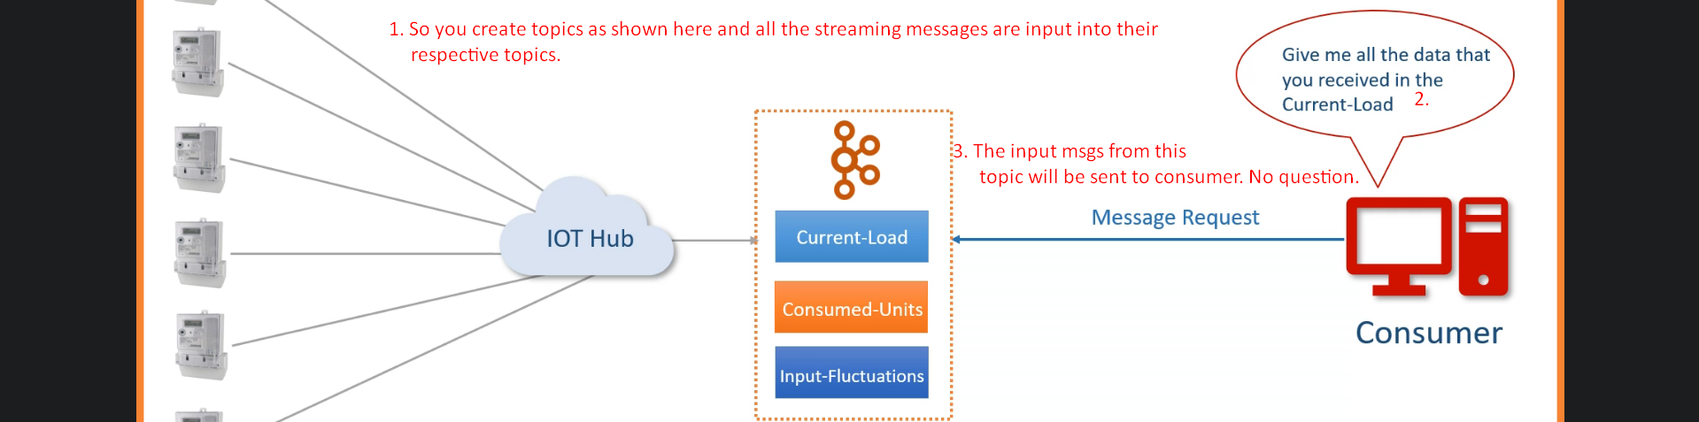
7. **Partitions**: A Smallest and independent portion of a topic
   1. A topic Size may be more than the size of a Kafka Server/Broker.
   2. **Solution**: P1 + P2 + … + Pn = Topic.  
      Where each partition will be assigned to one Kafka Server on a Kafka Cluster. Definitely we need Kafka Cluster.
   3. No of partition is design time decision by an architect.

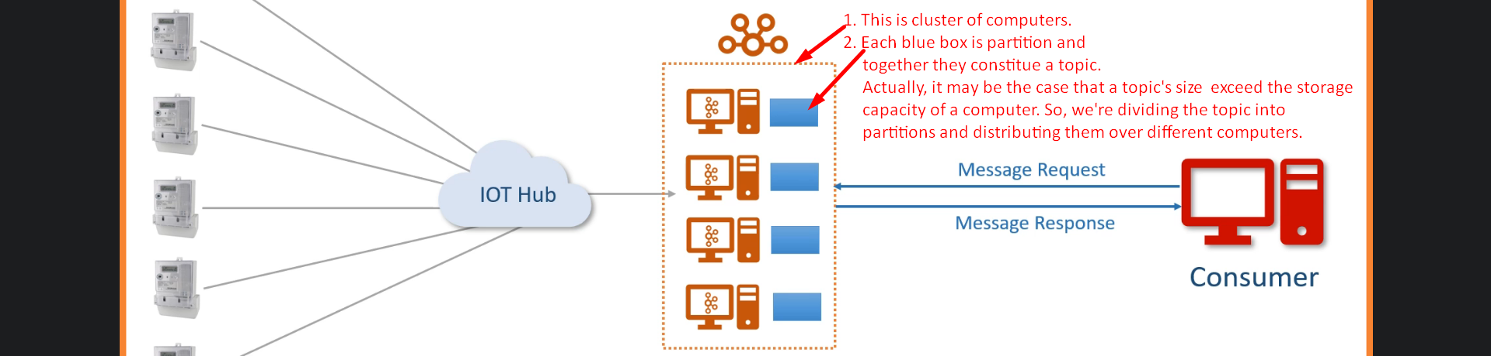

1. **Partition Offset**:
   1. 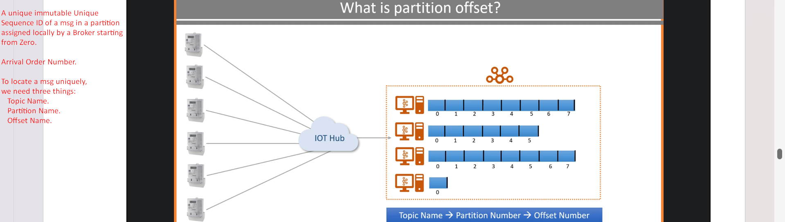
   2. 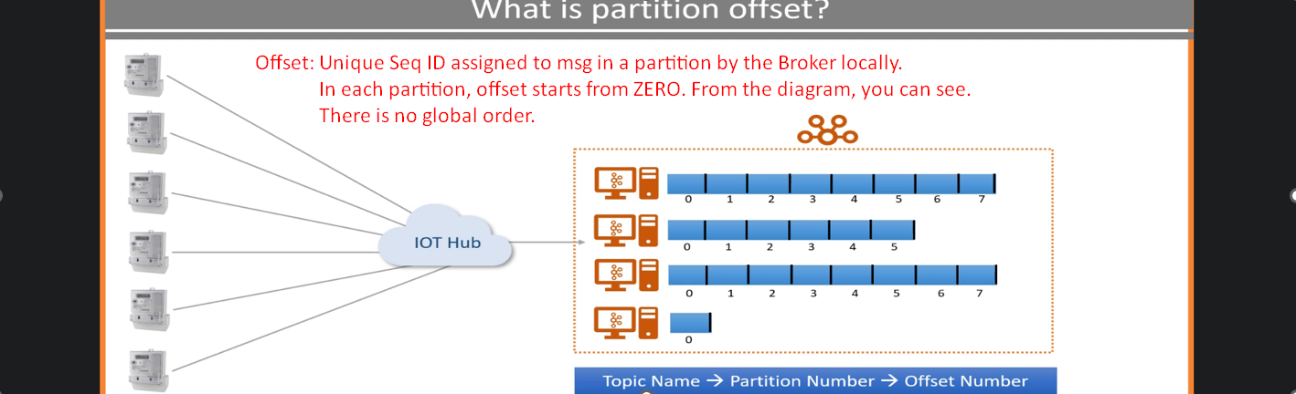
2. **Consumer Group**:
   1. A group of consumers to share a workload. **Purpose** to share workload.
   2. Multiple brokers to share workload when receiving the msgs from a number of producers.
   3. Multiple consumers to consume msgs coming in bulks.  
        
      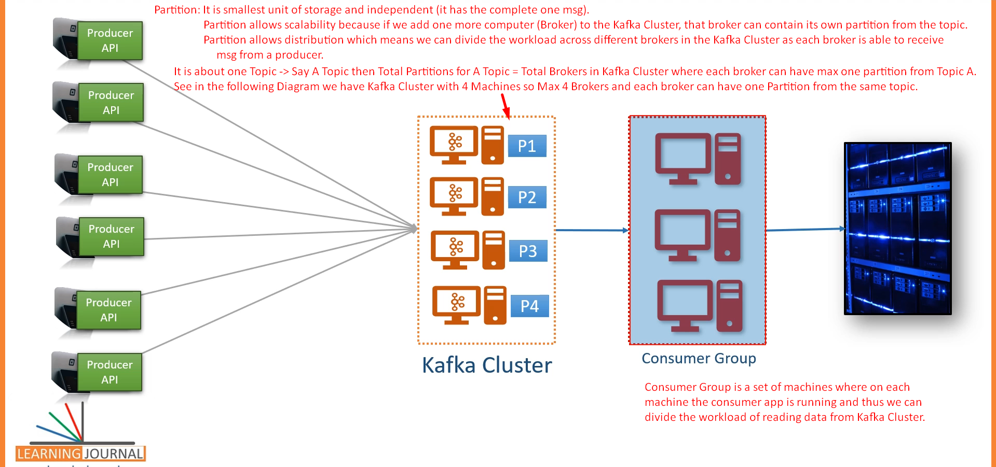  
      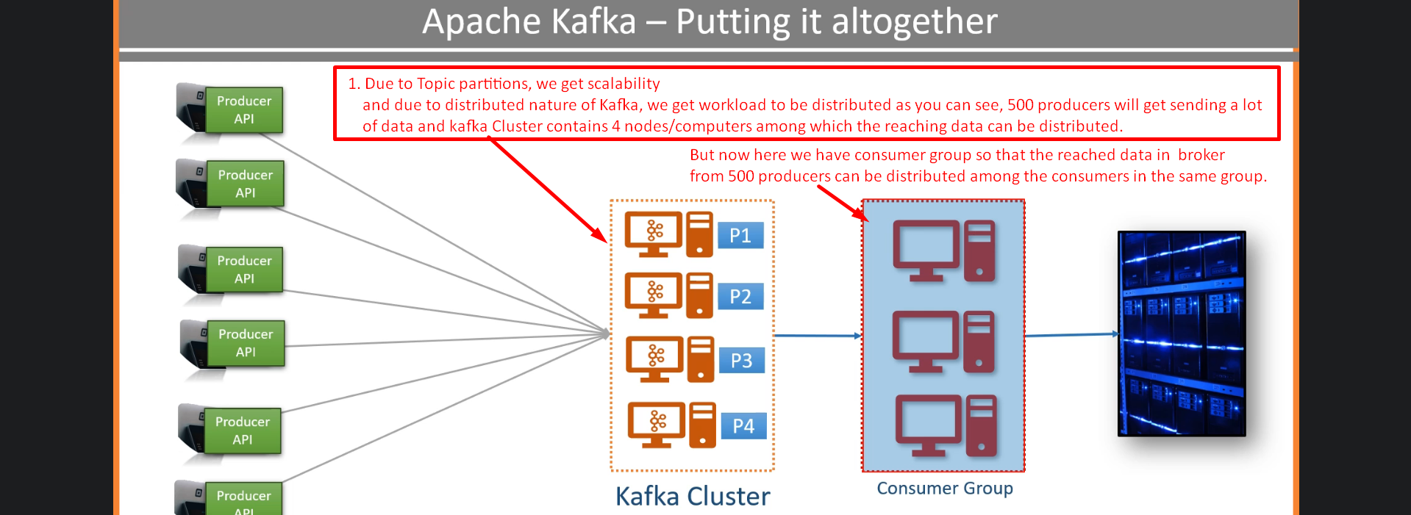

Kafka Connect Core Concepts

Some lectures are skipped. Please complete them.

8. Kafka Quick Start

1. Now we know about 5 components in Kafka  
   
2. **Agenda of this lecture**:  
   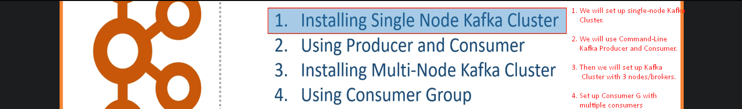
3. Installing Single Node Kafka Cluster
4. **Agenda**: Set up Single Node Kafka Cluster.
5. Skipping some parts. Please read.  
   
6. From above, we will use 2nd option 🡺 Download Apache Kafka Server from Confluent.io.
7. 

As per 2nd option, download Kafka Confluent Community Edition.  
  
  
  
  
  
  


1. How to start Kafka?
2. Starting Kafka is two-Step Process;
   1. **Start 01**: Starting Zookeeper Server.  
      
      1.   
           
         **rem Classpath addition for LSB style path**

**if exist %BASE_DIR%\share\java\kafka\* (**

**call :concat %BASE_DIR%\share\java\kafka\\***

**)**



* 1. **Step 02**: Run Kafka Broker.  
       
     

We created Single-Node Kafka Cluster.

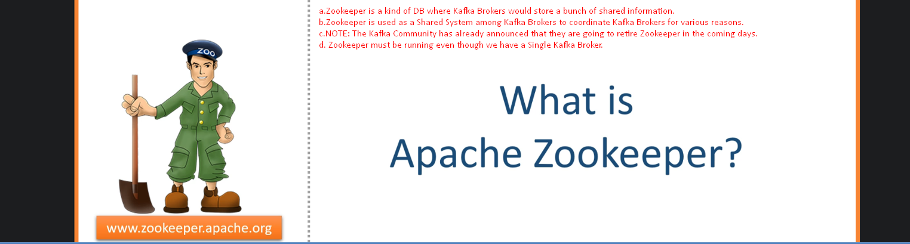

1. Using Command-Line Producer and Consumer
2. 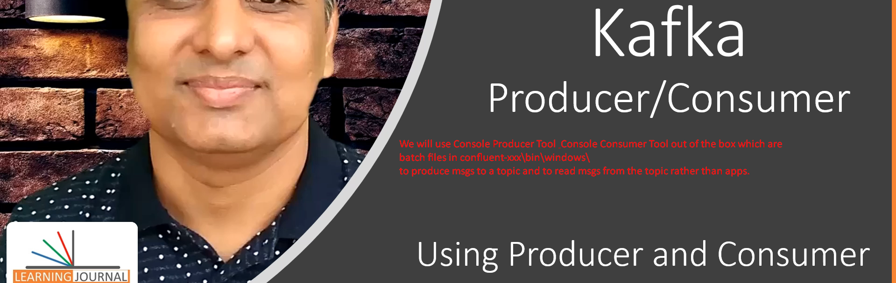
3. 
4. 
5. Sending and consuming Data
6. 1st create a topic using script 🡺   
   2nd Send Data to Kafa Server using script 🡺   
   3rd Consume Data from Kafka Server using script 🡺 



1. When creating topic, need to tell the # of partitions for a topic.  
     
   
2. Command **kafka-topic** options  
   
   1. **--create**: To create a topic
   2. **--partition**: To define partition number.  
      But how to decide the number?  
      
   3. **--replication-factor:** The number of copies for each partition to achieve fault tolerance. Useful only if we have two or more brokers in the cluster.
   4. **--bootstrap-server**: Initial broker network locations from Kafka Cluster for Kafka Clients (Producer & Consumer) to connect initially with Kafka Cluster’s brokers.



1. We will use this script to send data from console to Kafka Cluster.  
   
2. Command to read and send a Data File to Kafka Server.



1. Command to consume msgs from Kafka Server.  
   

11. Installing a Multi-Node Kafka Cluster

1. 
2. 
3. 
4. 
5. Create 2 more copies of the above file as we have total now 3 nodes.  
   
6. Let’s make changes related to properties 🡺 **broker.id**=0, **listeners**=PLAINTEXT://:9092, **log.dirs**=/tmp/kafka-logs-0 🡨 Where partition data is stored.

|  |  |
| --- | --- |
| 1st Broker Configuration |  |
|  | Broker.id=0 |
|  | **listeners**=PLAINTEXT://:9092 |
|  | **log.dirs**=/tmp/kafka-logs-0 |
| 2nd Broker Configuration |  |
|  | Broker.id=1 |
|  | **listeners**=PLAINTEXT://:9093 |
|  | **log.dirs**=../tmp/kafka-logs-1 |
| 3rd Broker Configuration |  |
|  | Broker.id=2 |
|  | **listeners**=PLAINTEXT://:9094 |
|  | **log.dirs**=../tmp/kafka-logs-2 |

1. Let’s start zookeeper but before that let us clean data sent earlier.   
   Go to c:/tmp/ 🡸 Delete everything.   
   Now run zookeeper.   
   zookeeper-server-start.bat <root>/etc/kafka/zookeeper.properties
2. Now run all three brokers  
   kafka-server-start.bat server-0.properties

kafka-server-start.bat server-1.properties

kafka-server-start.bat server-2.properties  
  
For each broker, a kafka-log-x directory will be created.

1. Now run kafka console producer & consumer.  
   kafka-console-producer --topic <name> --broker-list <list>  
   kafka-console-consumer --topic <name> --bootstrap-server <list>

12. Using Consumer Groups

1. 
2. **Agenda**: We already have 3-Node Cluster. Let us do
   1. A topic with 3 partitions.
   2. Two consumers in a consumer group.
   3. Start Producer and Consumer.
3. Create Topic with 3 partitions.  
     
   Starting a consumer .  
   This option **--group < name>** is important when starting multiple consumers in a same group. Starting another consumer in the same group 🡺 **--group <same-name>**  
   **NOTE: Multiple consumers cannot read from same partitions.**  
   Starting Kafka Console Producer and passing CSV file having **1097 records**.  
   **Brief**: We have ZooKeeper up, three Brokers Up, three partitions, Two consumers in the same group.
4. This is what will happen after starting kafka console producer above.  
   Consumer one has been assigned two partitions and consumer 2 has been assigned one partition.  
   
5. 

**NOTE**: Total = 1244 + 663 = 1907



1. Let’s see the Data Directory for each Kafka Broker where partition directory is maintained.
2. 
3. 
4. 
5. 
6. Let’s use the tool **kafka-dump-log.bat**

**Dumping Partition Data from Broker with broker.id=0**

1.   
   You can dump the data itself too. But we’re skipping.
2. Let’s dump the other partitions’ log.  
   **Dumping partition data from broker with broker.id=1**   
     
   **Dumping partition data from broker with broker.id=2**

13. Configuring Your Development IDE

1. double dot means relative path to the location where we are running script.
2. 
3. 
4. 
5. 
6. 
7. 
8. 
9. 
10. 
11. 
12. 

14. Understanding Storage Architecture

1. **Agenda**:
   1. In this section, we’re going to understand Kafka **internals and some architectural concepts**.  
      **NOTE**: These fundamental concepts are critical for the rest of the course.
2. 
3. 3 Primary Responsibilities
   1. Receive msg from Producer and acknowledge.
   2. Store in a log file to safeguard from potential loss and/or to support non-realtime reading.
   3. Deliver when requested by a consumer.
4. 
5. Not completed. Do complete it 😊

15. Kafka Topic and Partitions

1. 
2. 
3. 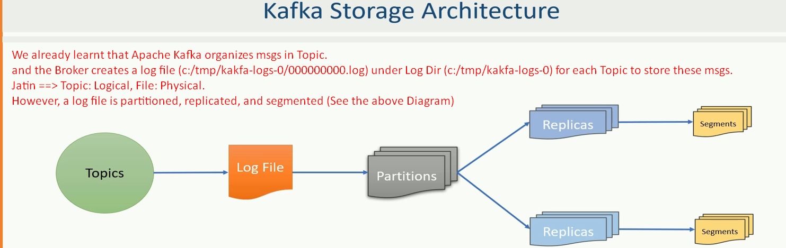
4. 
5. 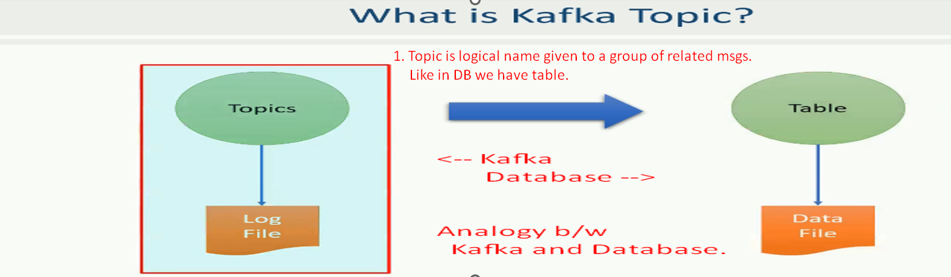
6. 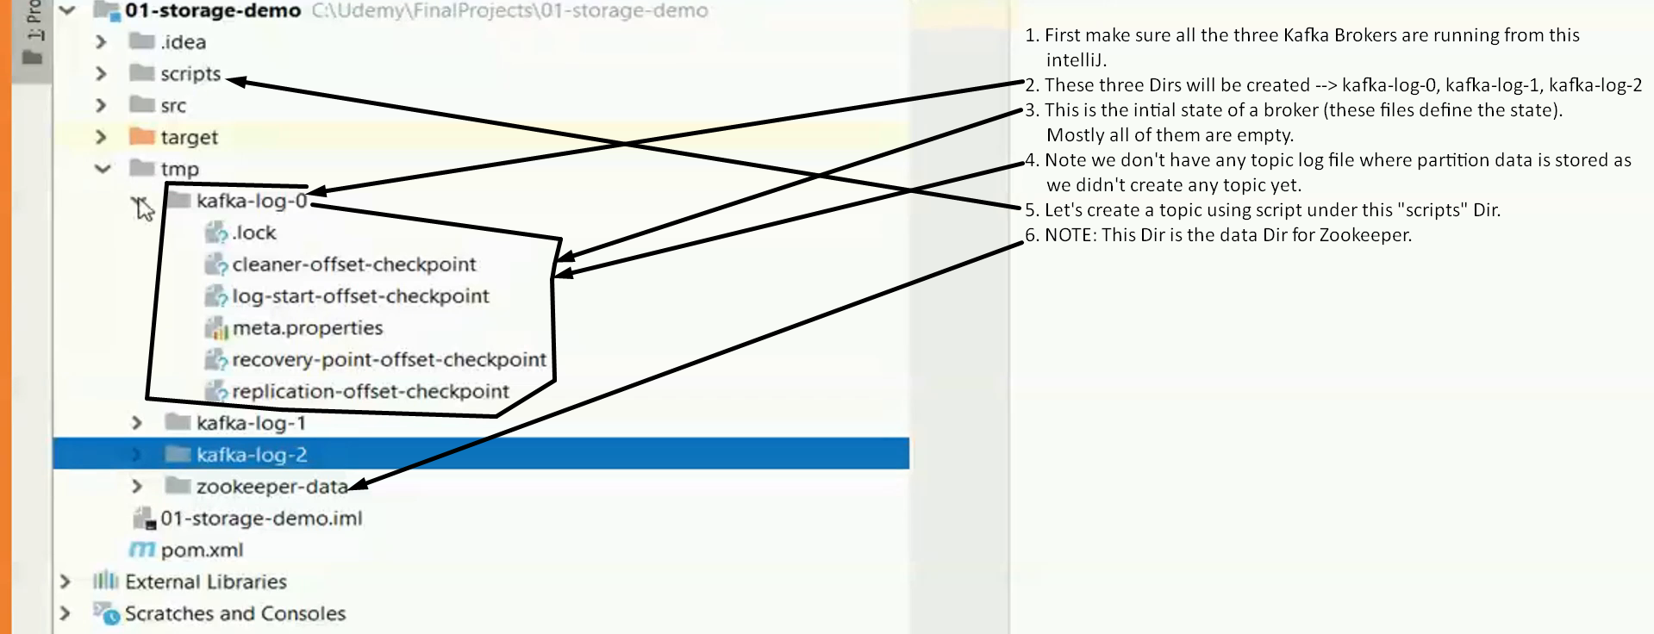
7. 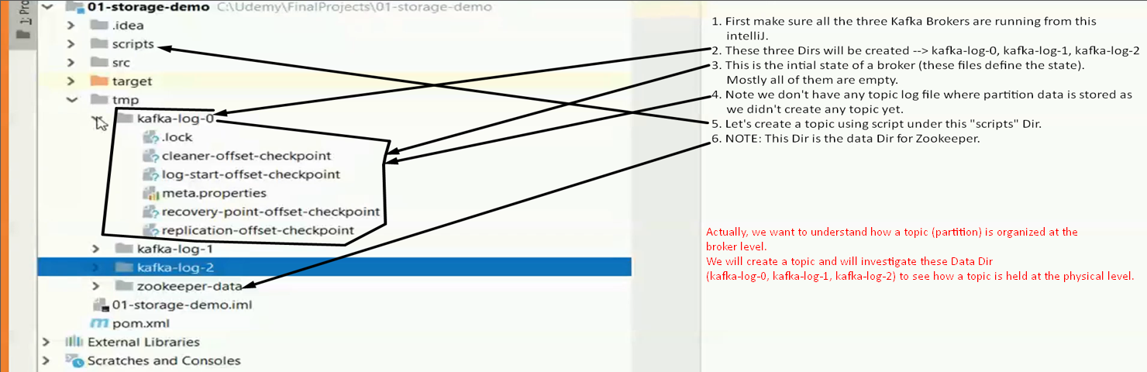
8. 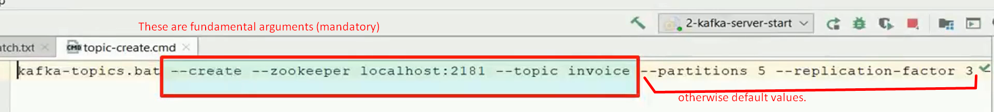  
     
   
9. 
10. Physical file created for each partition for a topic.
11. 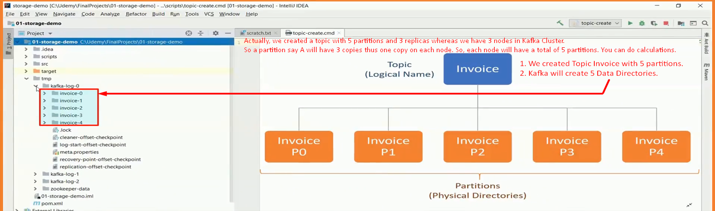

16. Kafka Topic Replication

1. 
2. 
3. 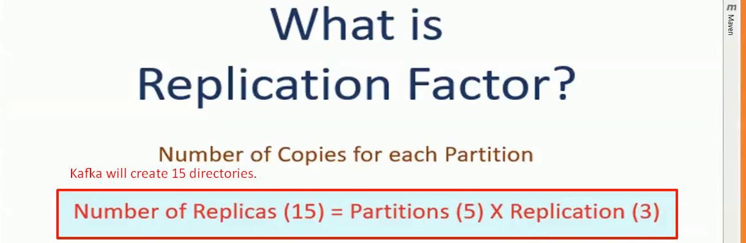
4. 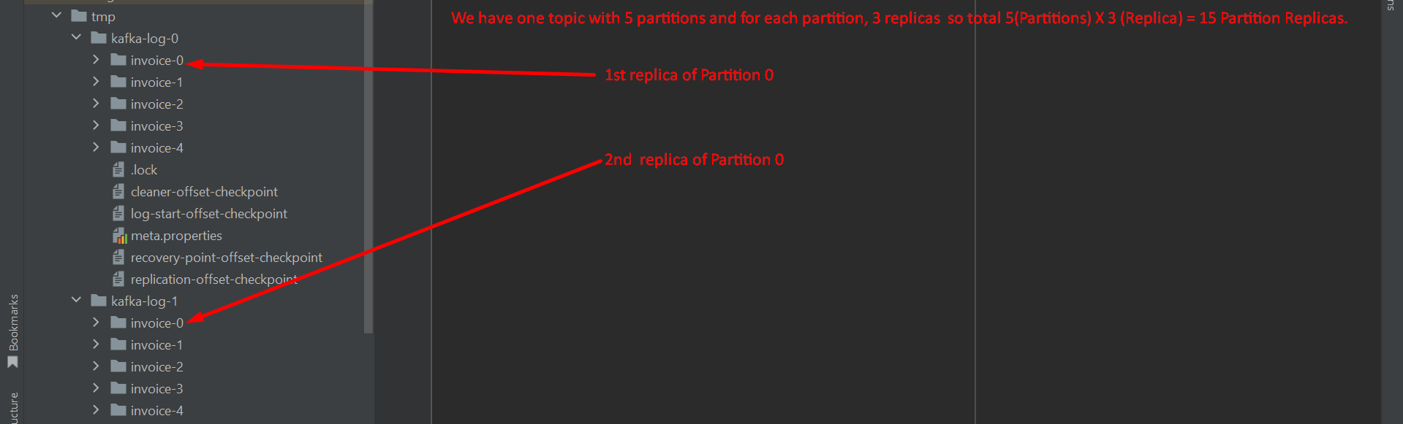

17. Partition Leaders and Followers

1. 
2. 
3. Two categories of partitions
   1. Leader Partitions: No of Leader Partitions based on partition.
   2. Follower Partitions : No of Follower Partitions based on replication-factor number

18. Kafka Log Segments

1. 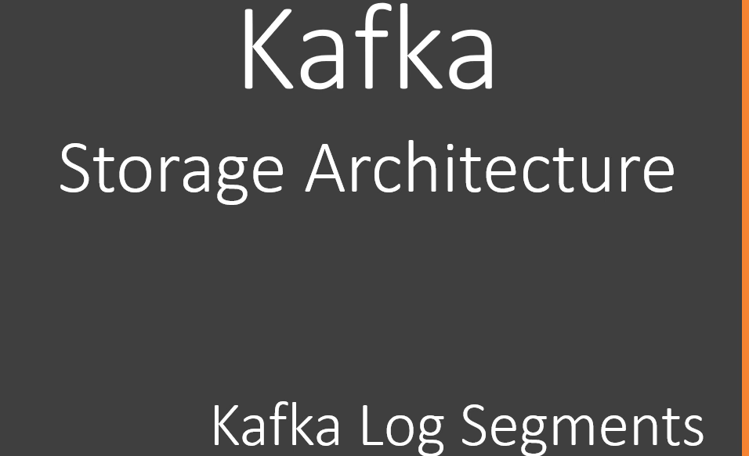
2. 
3. The msgs are stored in log file under partition directory.
4. But instead of storing all the msgs in a single log file, kafka generates several small log files. 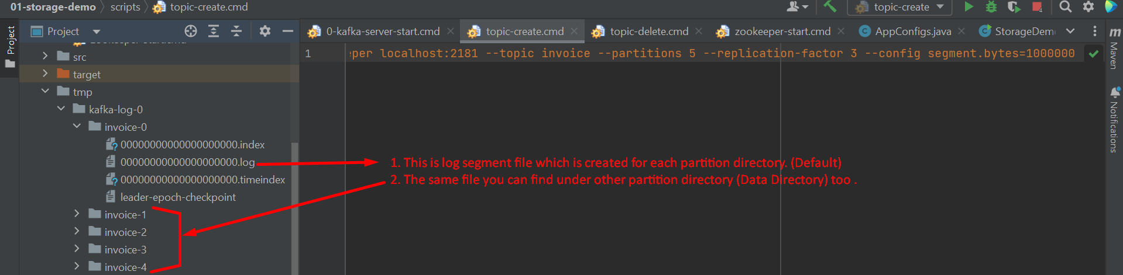
5. 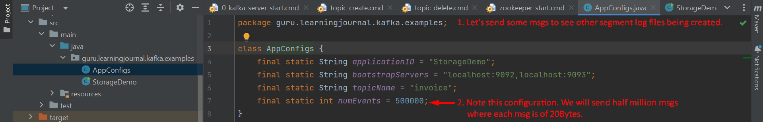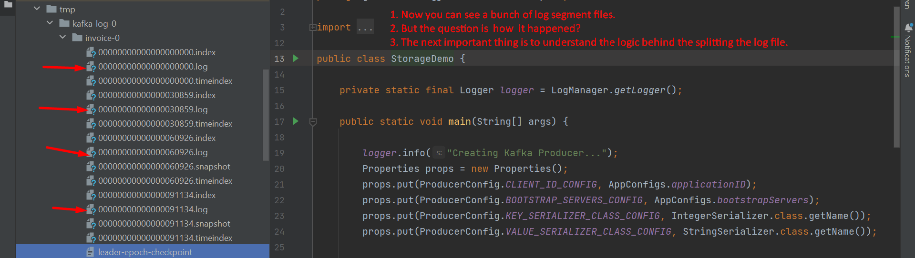
6. 
   1. When a partition starts receiving msgs, it stores the msgs into the first segment 00000000000000000000.log.
   2. When the segment limit is reached, it closes the existing segment log file and creates a new segment log file.
   3. **Default limit** is 1 GB or a week of data.   
      Whatever is reached first.
   4. We have set the limit to 1MB.   
      That’s why we can see the segment log files earlier in our case.

19. Kafka Message Offsets

1. 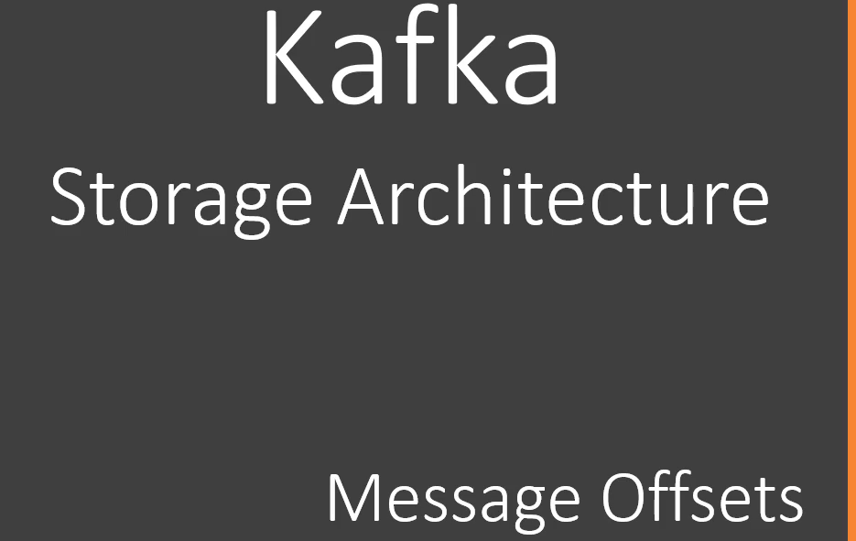
2. 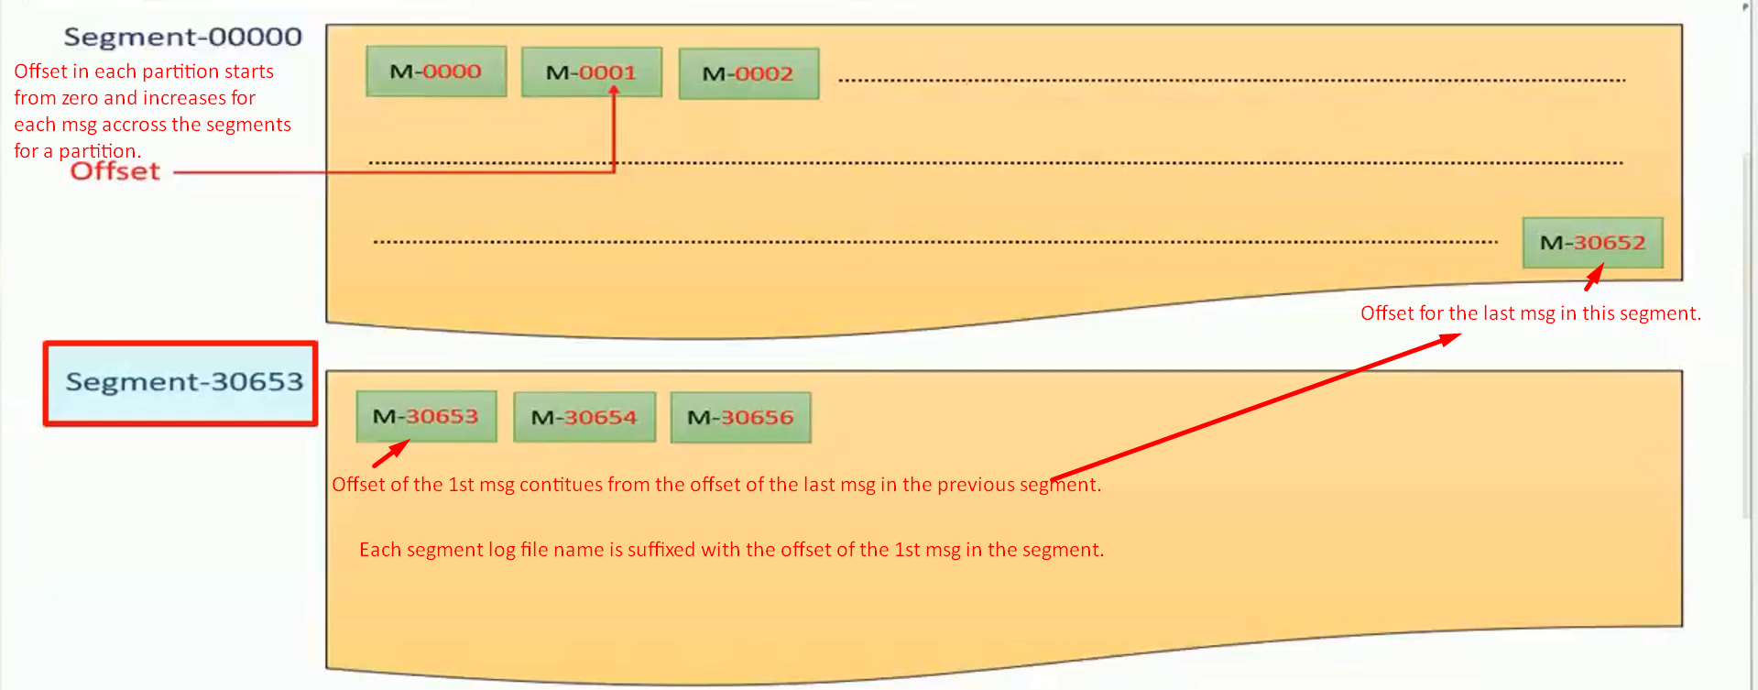 Each Kafka Msg within a single partition is uniquely identified by 64 bit integer offset.  
   Offset numbering continues across the log segments for a partition.  
   The offset of the 1st msg in a new log segment will be the offset of the last msg in the previous log segment + 1.
3. 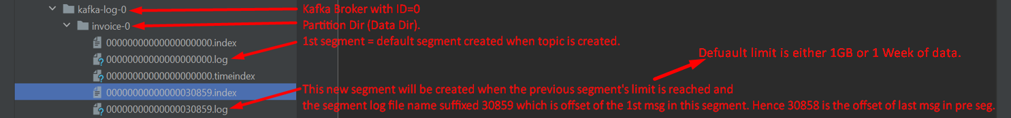
4. 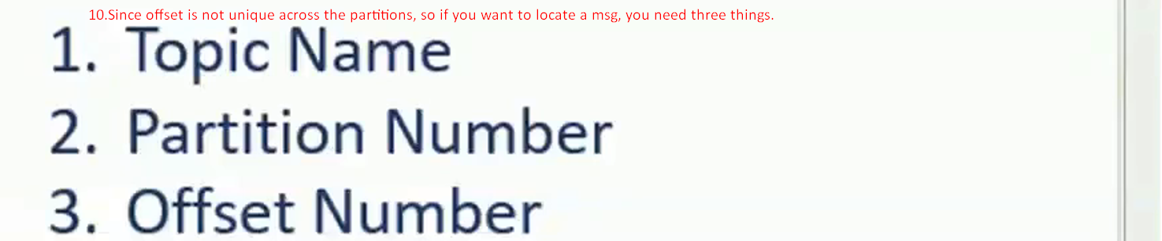

20. Kafka Message Index

1. 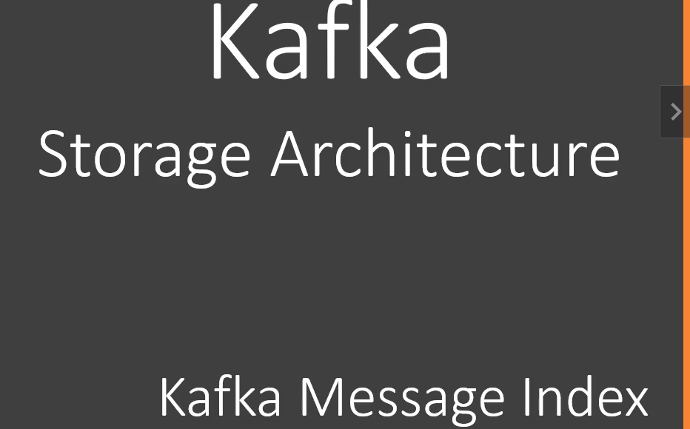
2. As we studied already that Kafka allows consumer app to read msgs based on offset but if we think in terms of DB Query where we seek data based on column name and value, this uniqueness arrangement by kafka like querying msg based on offset (which is an arrival number) seems strange.
3. However, this numbering may not be a problem for stream processing app as they want to process msgs in seq.
4. For example, Loyalty Point calculation app may want to read customer id and amounts for each msg.   
   For this, the app asks for 10 msgs starting with offset 0 it means from 0 to 9 offsets.  
   It will process them and again will ask for next 10 msgs starting from offset 10 to 19.  
   When consumer app demands for msgs with offset, the kafka should be able to send them.   
   For this, Kafka maintains index file along with log segment file.  
   
5.    
   Index file is also put along with Log segment file.
6. 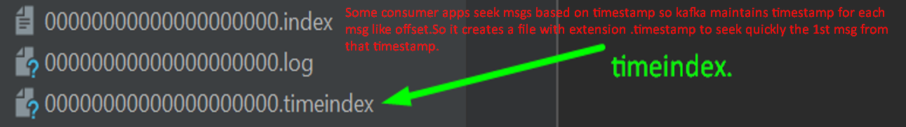

21. Understanding Kafka Cluster

1. 
2. **Cluster**: A group of brokers working together to share workload.
3. **However, the notion of clustering brings out two critical questions**.  
   
   1. **Cluster Membership**: Who manages Cluster membership?
      1. In a typical distributed system, there is a **Master Node** managing list of active brokers. how does it knows
         1. When an existing broker is crashed.
         2. When a new Broker joins the cluster.
   2. **Administrative Tasks**: Who performs the routine administrative tasks in the cluster.
      1. When an existing Broker having some responsibilities crashes, to whom those responsibilities are to be assigned.
4. 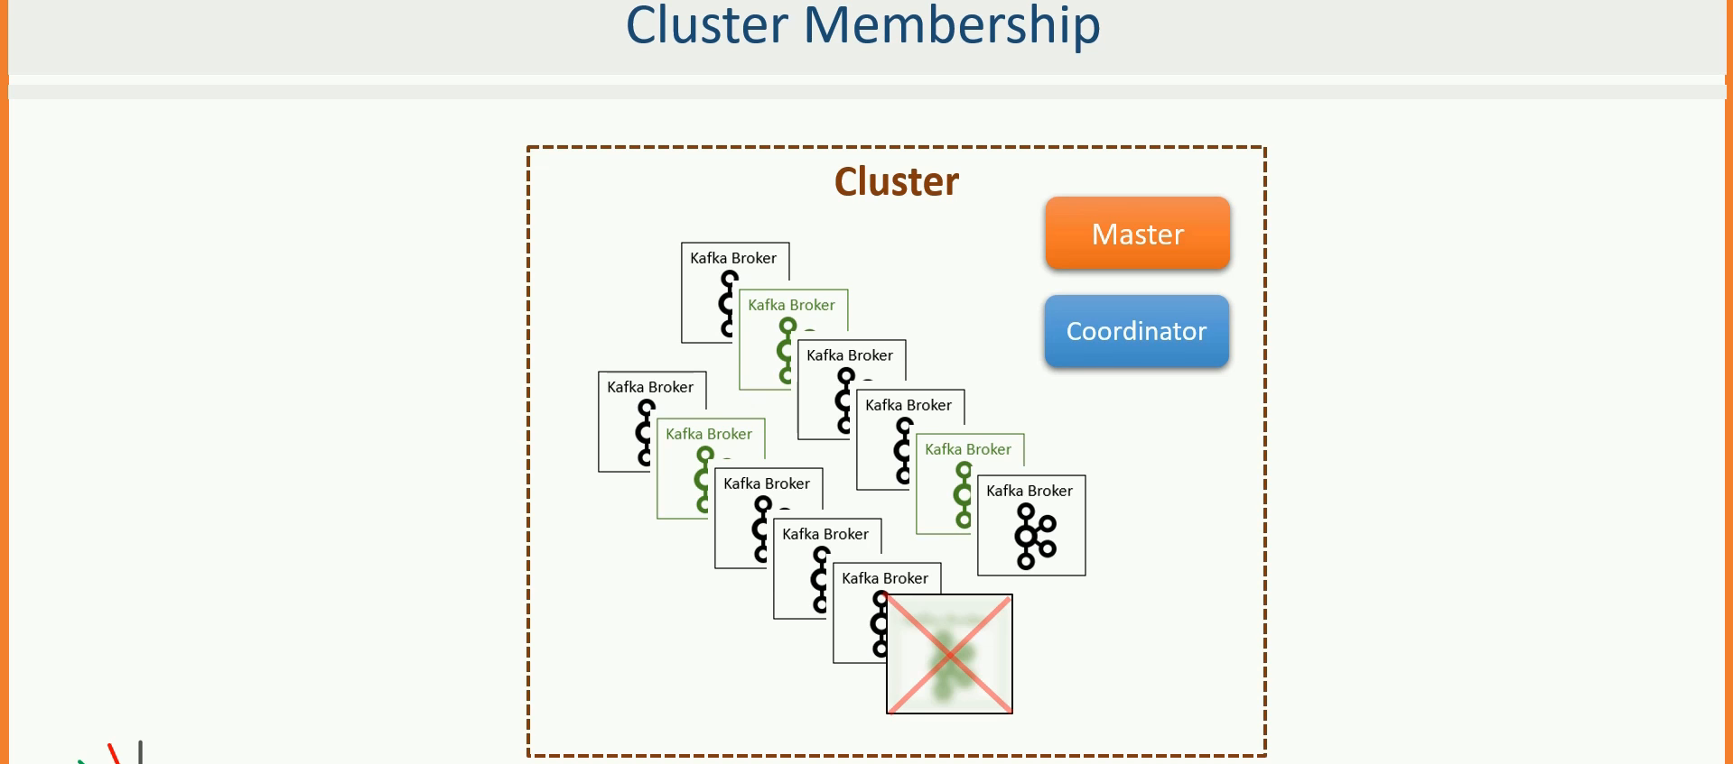

22. Zookeeper in Kafka

1. Foundation before proceeding further.
   1. Kafka cluster doesn’t follow Master-Slave Architecture.

So, it is Masterless Cluster.  
However, it uses Zookeeper to maintain list of active Brokers.

* 1. Each **ephemeral** node created in Zookeeper is referred to as ZNODE. (Do not worry about it. Study further to understand)
  2. Each broker has a unique number defined in server.properties file.
  3. When we start a broker, it gets the Zookeeper’s coordinate in server.properties file.

1. When a broker joins cluster, an ephemeral node (called ZNODE in Zookeeper) is created in Zookeeper’s DB and this node will remain active as long as its corresponding Broker is active. Actually, it represents an active session for that broker. As broker goes down, this ephemeral node (ZONDE) also goes done.  
   This is how active brokers list is maintained.
2. 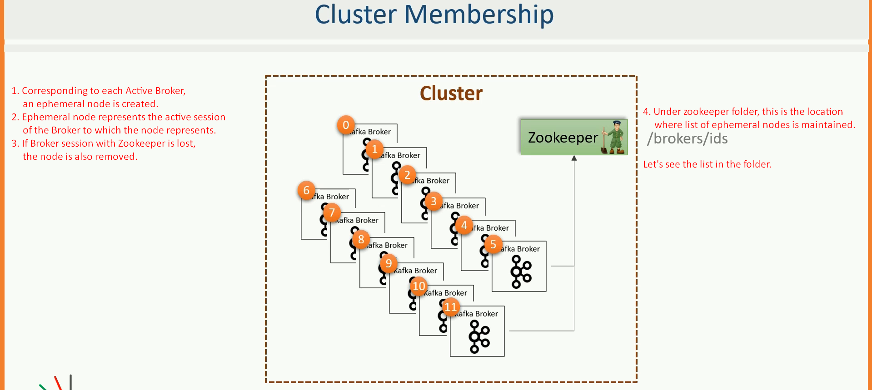  
     
   Let’s start Zookeeper and go inside its DB to list all active sessions (ZNODES)  
   First start zookeeper as you start when run command zookeeper-shell.bat localhost:2181 to connect with zookeeper’s DB. Then Run ls command to see active brokers as shown below.  
   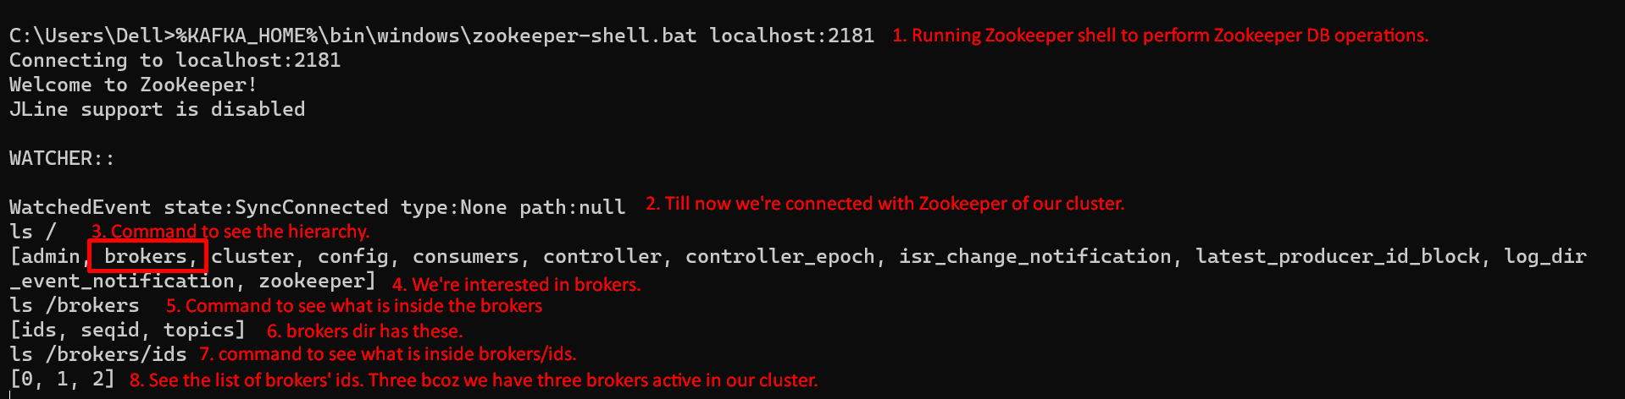  
   

23. Kafka Cluster Controller

1. 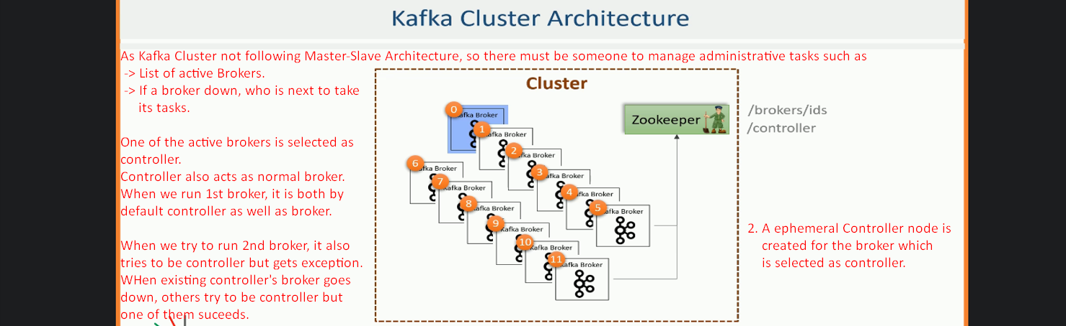
2. Commands to see selected controller.  
     
     
   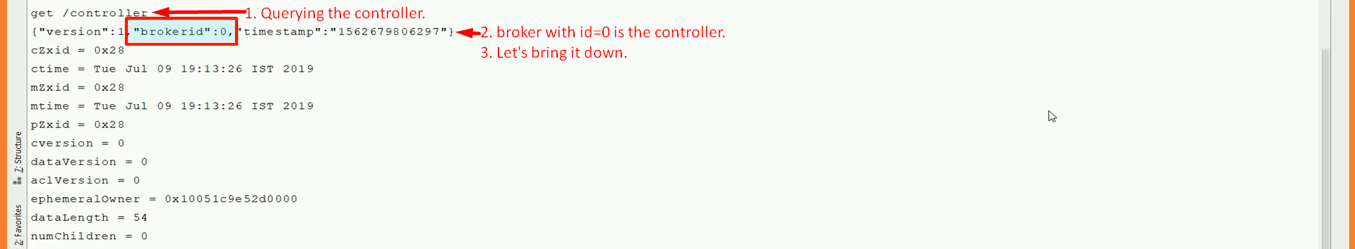  
     
     
     
     
     
     
   

24. Partition Allocation and Fault Tolerance

1. Assignment of 30 replicas (10 Partitions X 3 Replicas = 30 Replicas) among 6 brokers (3 Brokers on Rack1 and other 3 Brokers on Rack2) to achieve even workload and Fault tolerance.
2. 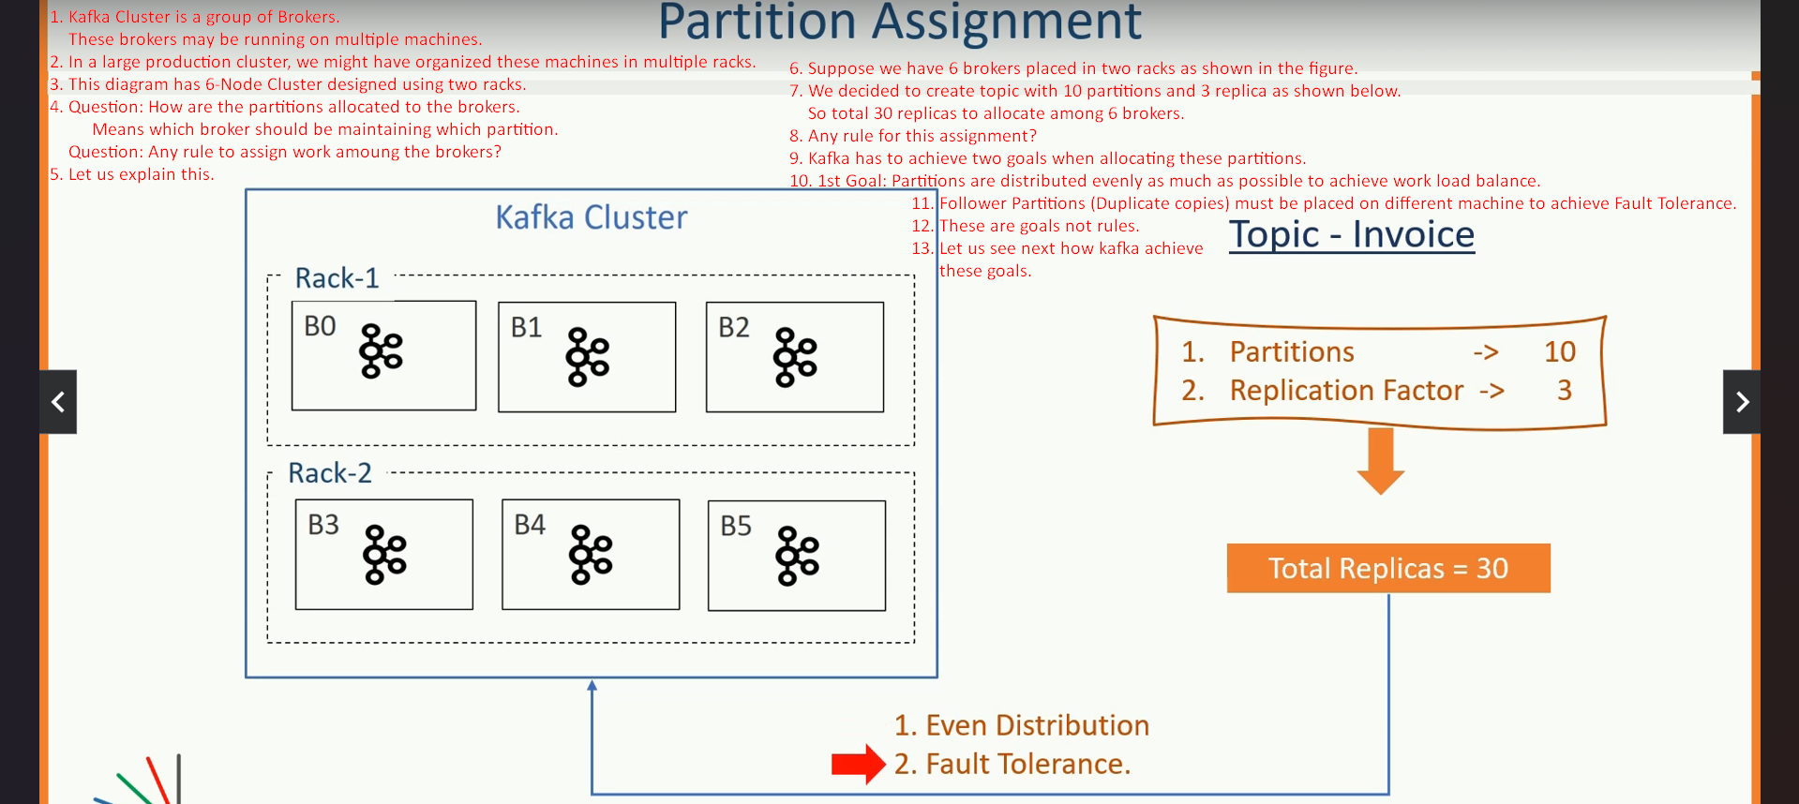
3. We will do the following:  
   
4. Following creating Ordered List of Brokers from two different Racks.  
   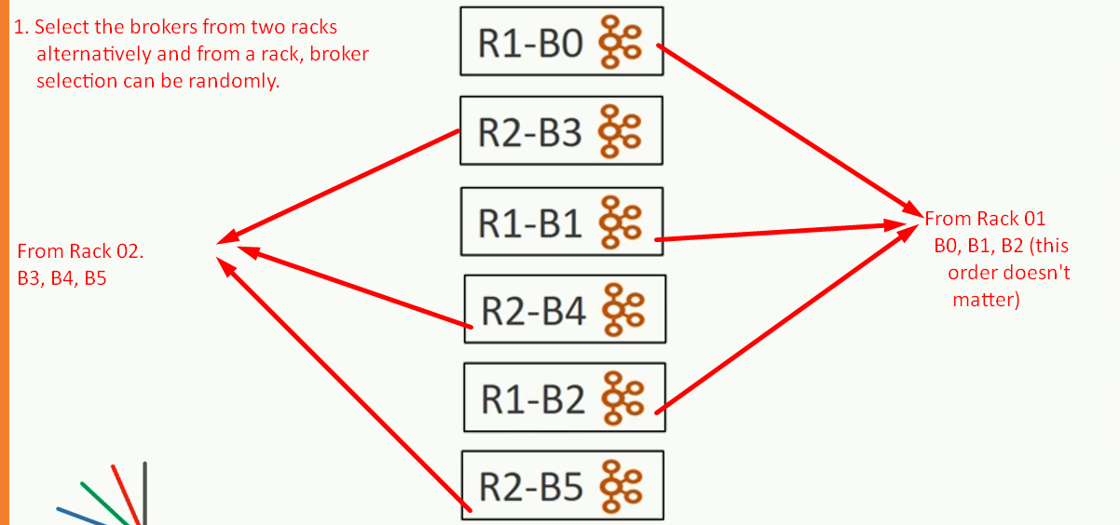
5. Let’s assign the replicas starting from leader ones then follower ones to the ordered list from top to bottom.  
    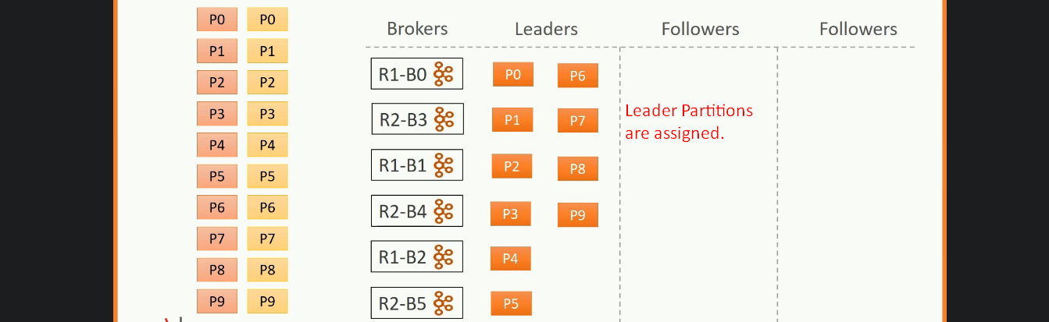  
   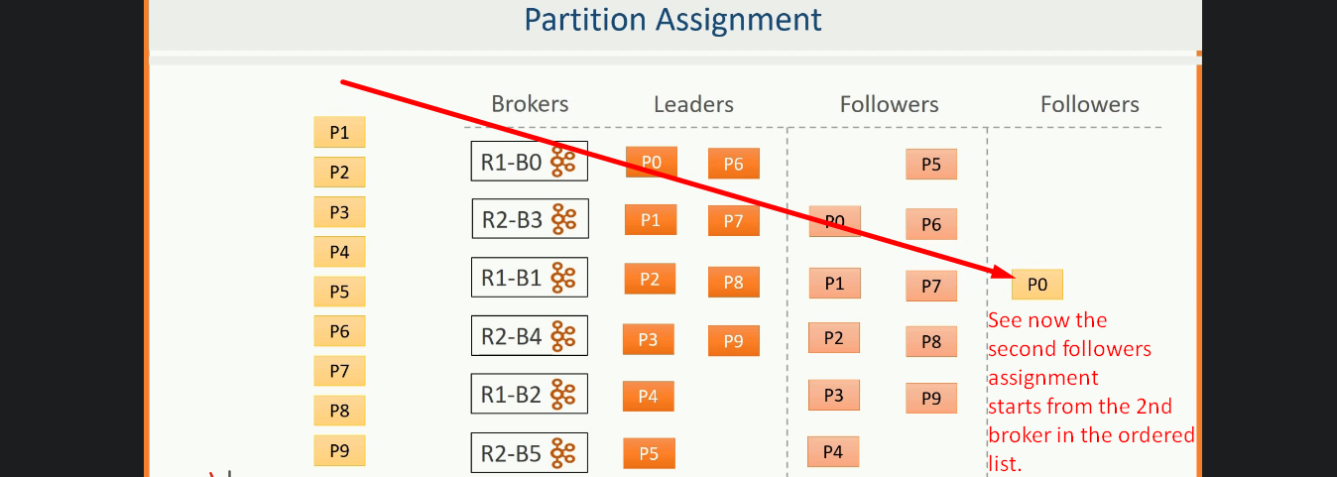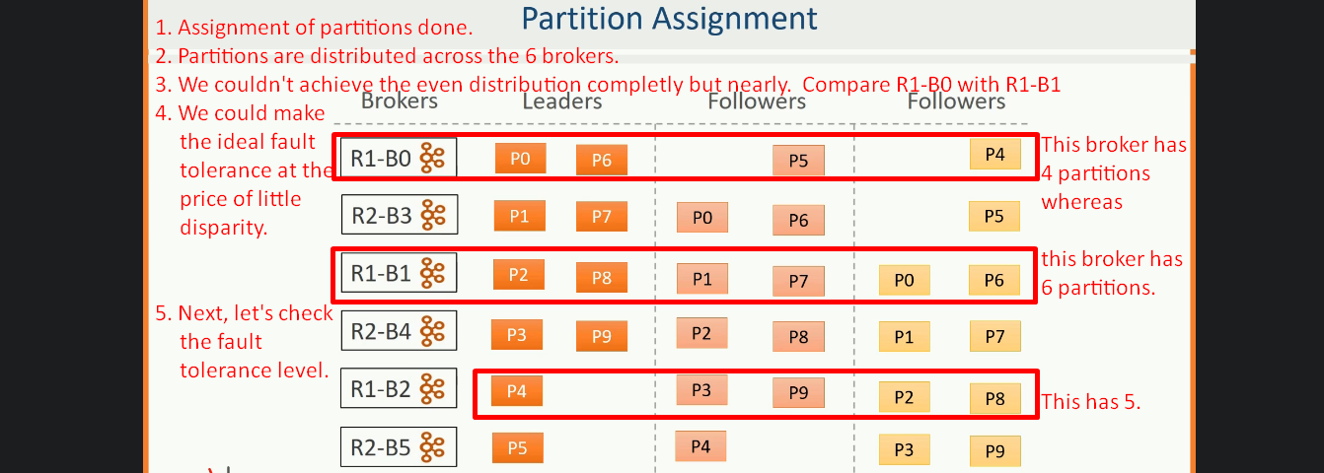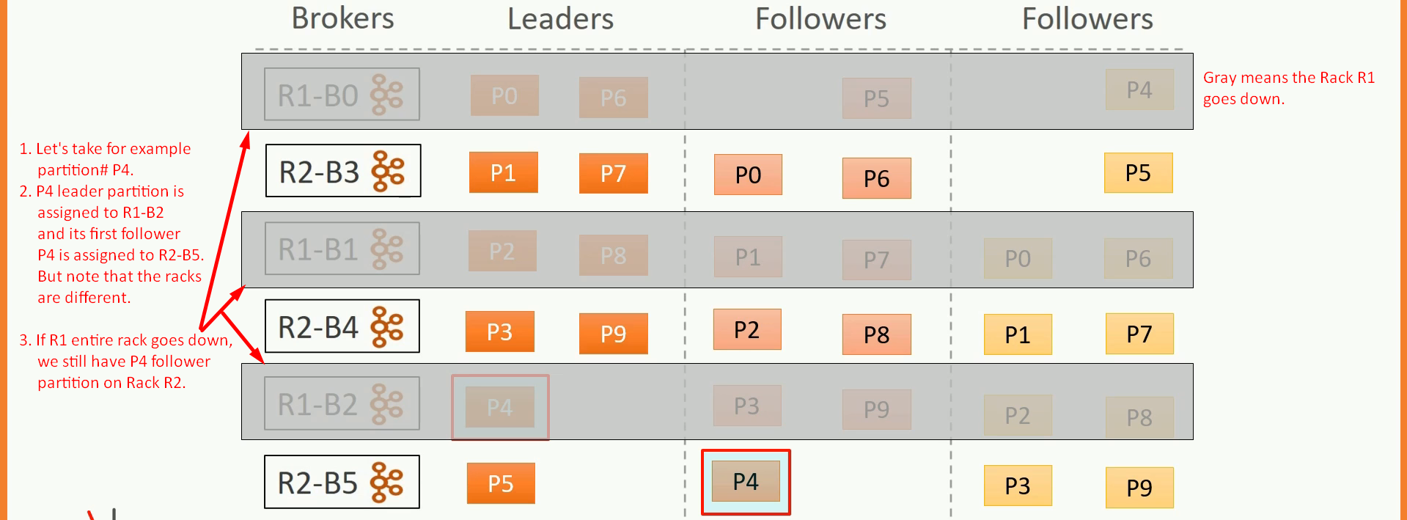

25. Partition Leader vs Partition Follower

1. 
2. **Agenda**:
   1. Responsibility of Leaders and Followers.
3. d

29. Introducing Kafka Producers

1. Kafka Producer API is available in other languages too. 🡺 Java, C++, .NET, Go, Python, Node.js
2. Except for Java API, all the other Language APIs are implemented using **librdkafka** Library based on C/C++.

30. Creating Your First Kafka Producer

1. Refer to Overall-Kafka-Code.docx as this lecture has mainly code.

31. Producer Record

1. ProducerRecord.java 🡺 Wrapper around a kafka msg to be sent over network to kafka cluster.   
     
   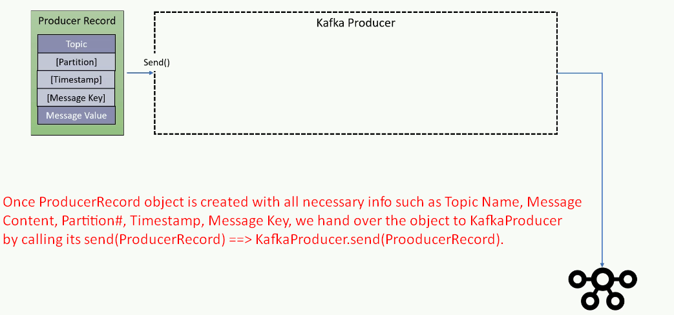

32. Producer Serializer

1. 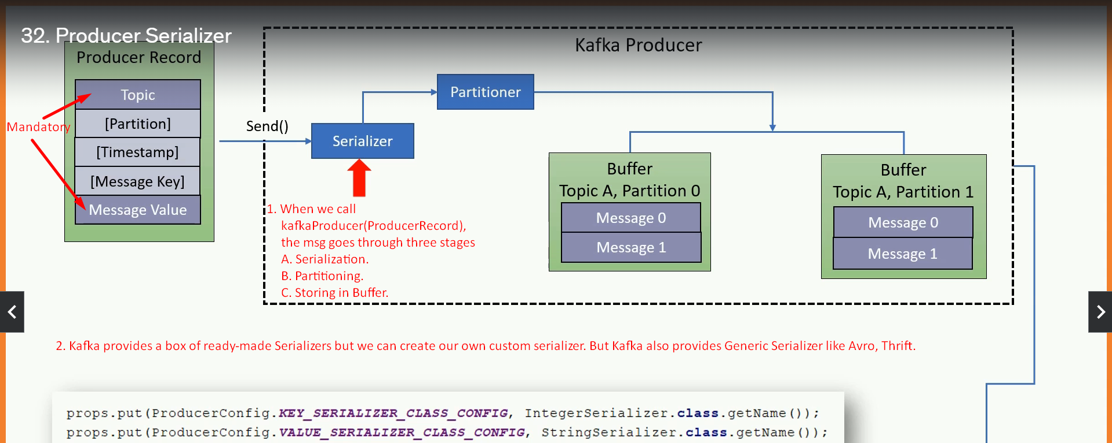 kafka gives you the following options with respect to serialization:
   1. Ready-made serializers out of box as shown in above snapshot.
      1. IntegerSerializer.java
      2. StringSerializer.java
   2. an option to use a **generic serialization** library like **Avro or Thrift**.
   3. We can create **custom serializers**.
2. In some lectures, we will talk about JSON serializer and will show the process of creating and using a custom serializer.

33. Producer Partitioner

1. 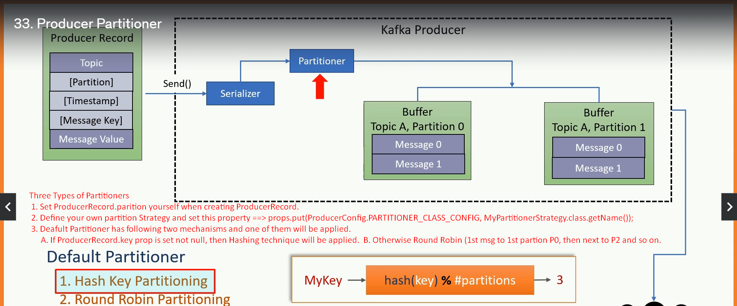
2. In case of Hash Key Partitioning:
   1. # of partitions decision is design time decision.
   2. If later on, it is changed, redistribute msgs.
   3. Msg with the same key will go to the same partition.
3. Round Robin: 1st msg to 1st partition P1, 2nd msg to Second partition P2 and so on.

34. Message Timestamp

1. Refer Overall-Kafka-Code.docx

35. Producer Message Buffer

1. Once msg is serialized then its partition# is determined, the msg sits in its buffer.
2. KafkaProducer consists of partition-wise buffer space where msg sits to be transmitted.
3. The Producer also runs background I/O thread responsible to turn these records into requests and transmit to the Kafka Cluster.
4. Two reasons for a buffer:
   1. **To support asynchronous request**: As soon as we call KafkaProducer.send(ProducerRecord), the msg is stored into buffer and control returns.
   2. **Network optimization**: Batch processing.
5. 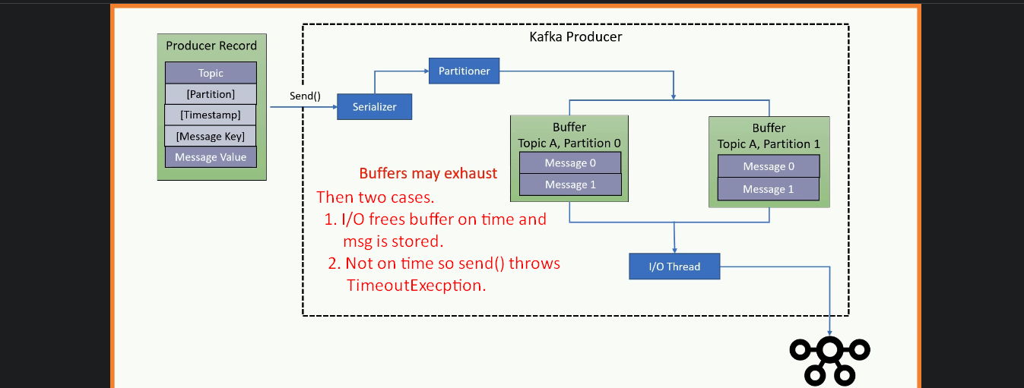
6. The default Producer Memory is 32MB. If timeout, then increase it.  
   buffer.memory=64MB

36. Producer IO Thread and Retires

1. Producer Retry which is performed by Producer I/O Thread in the background.
2. The Producer background I/O thread is responsible for transmitting the serialized msg that is waiting in the topic partition buffer.   
   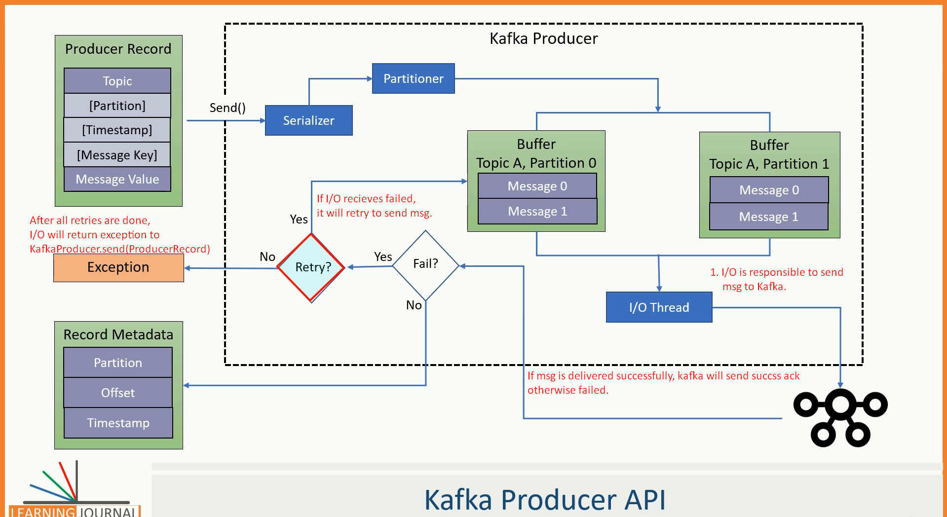
3. properties.setProperty(ProducerConfig.RETRIES_CONFIG, Integer.toString(Integer.MAX_VALUE));

37. Summarizing Producer

1. Just brief for this section.

38. Horizontal Vs. Vertical Scalability

1. Apache Kafka was designed with scalability in mind.
2. We can scale Producers, Brokers.
3. We can scale an individual producer using multithreading techniques.  
   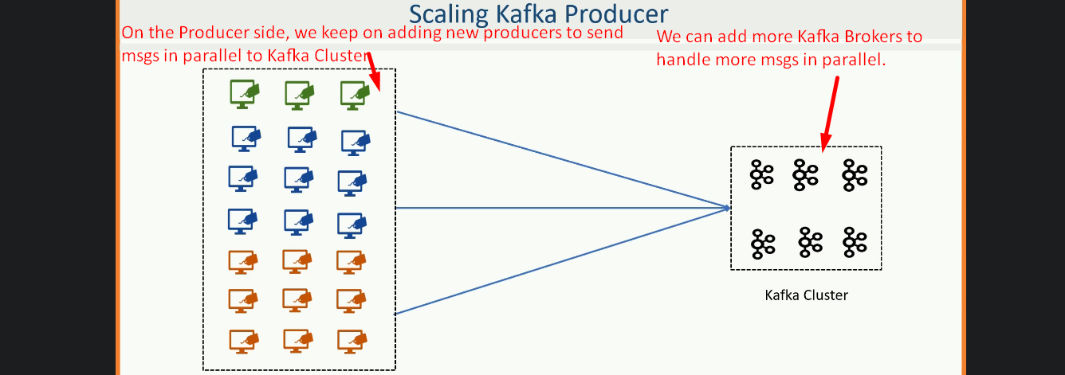  
   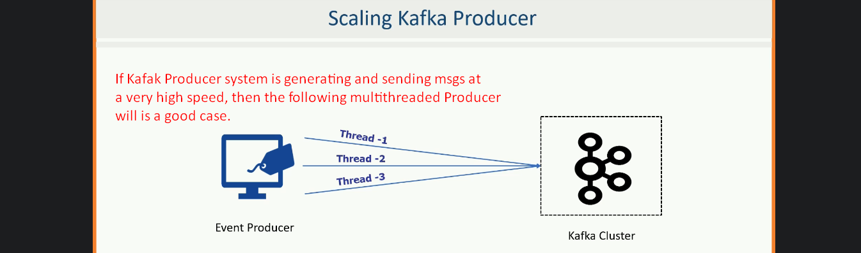

39. Producer Multi-Threading Scenario

1. 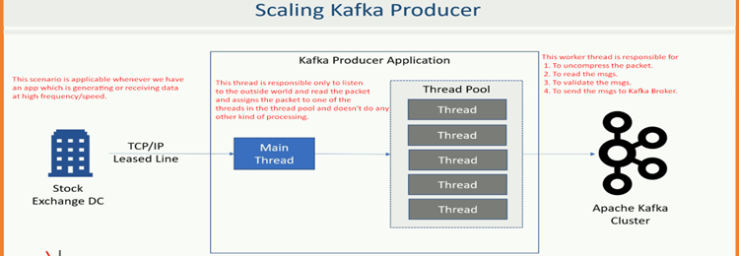

40. Creating Multi-Threaded Kafka Producer

1. Refer overall-kafka-code.docx

41. At least Once Vs. At Most Once

1. Apache Kafka provides msg **durability guarantee** by committing the msg at the partition log.  
   Followers in ISR list provides fault-tolerance by copying msgs from the Leader.  
   So, once the msg is saved to the leader and all the followers, the msg is said to be fully committed.
2. But the possibility of duplicate msg in case producer retries if acknowledgement does not reach may be due to network issue.
3. **Semantics**:
   1. **At Least Once semantics: Default Behavior**
      1. It means if msg is stored by Broker but acknowledgement doesn’t reach Producer (like due to network issue), the Producer will retry and the same msg will be saved by Broker so duplicate which is notation for “At Least Once”.
   2. **At Least Most Once semantics**
      1. If we set retry=0, the Producer will not retry. So, no duplicate msg but we may lose msg.
4. 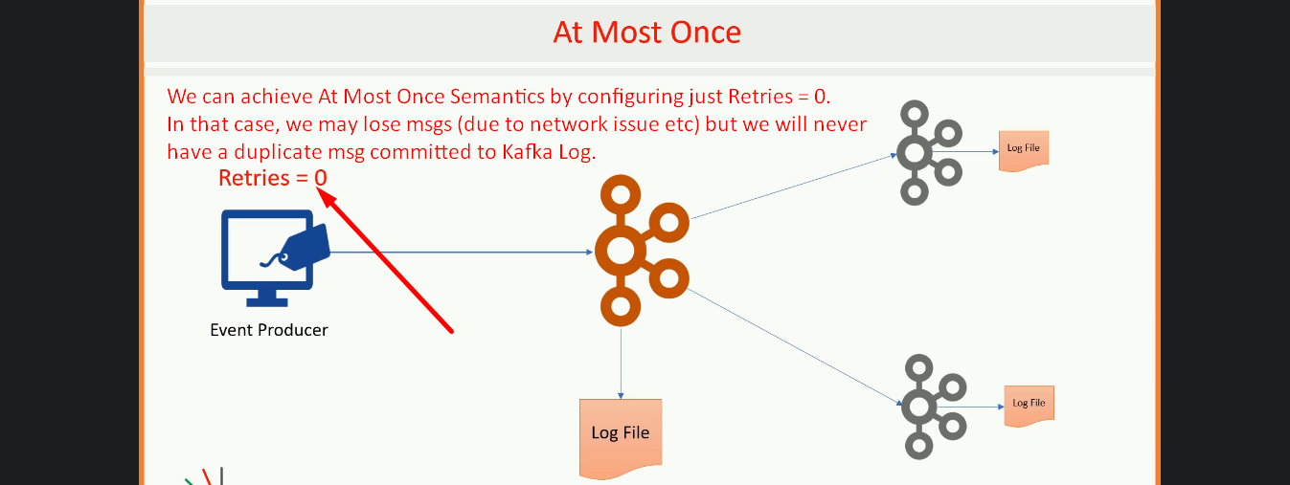

42. Exactly Once - Producer Idempotence

1. We don’t want duplicate msgs nor do we want to lose any.   
   To meet **Exactly Once Requirement**, Kafka offers an **idempotent producer configuration**.
2. **enable.idempotence=true**
3. Many things will happen internally after that configuration but the main:  
   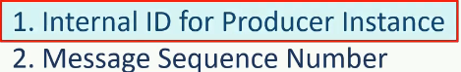
4. 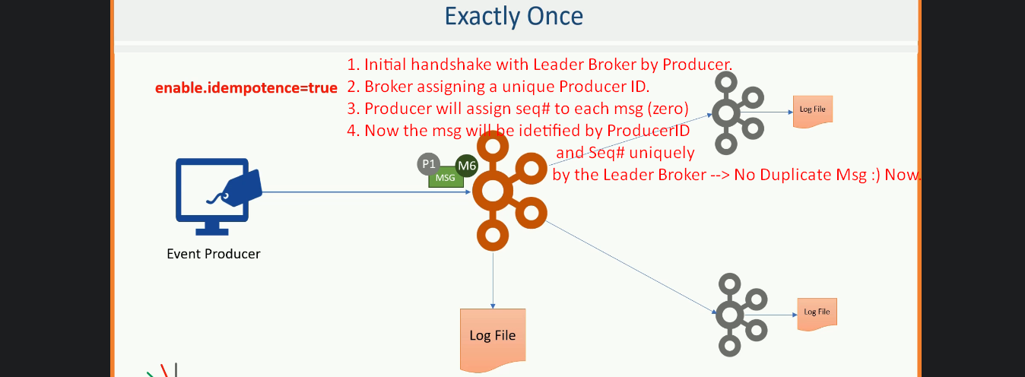

43. Transactions in Kafka Producer

1. Refer to Overall-kafka-Code.docx.

44. Working with Types and Serialization

1. 
2. Till now we sent just string msgs but realtime, it is not the case. But want to send some complex java objects.
3. Basically, we have two critical questions:  
   
4. Basically, what we want to achieve is straightforward.
   1. **Use A Schema Definition Language**: We want to be able to define a msg schema using some simple schema Definition Language(Even this can be automated as we did in Banking app).
   2. **Auto-Generate Java Class Definition**: Then we want our IDE or some java build tool to generate Java Class definition from the Schema definition automatically.
5. However, there are two alternatives those can be suggested for your Kafka App.  
   
6. Can we develop **reusable serializer and deserializer** and can apply that to all the Java Types.  
   Yes, we can.